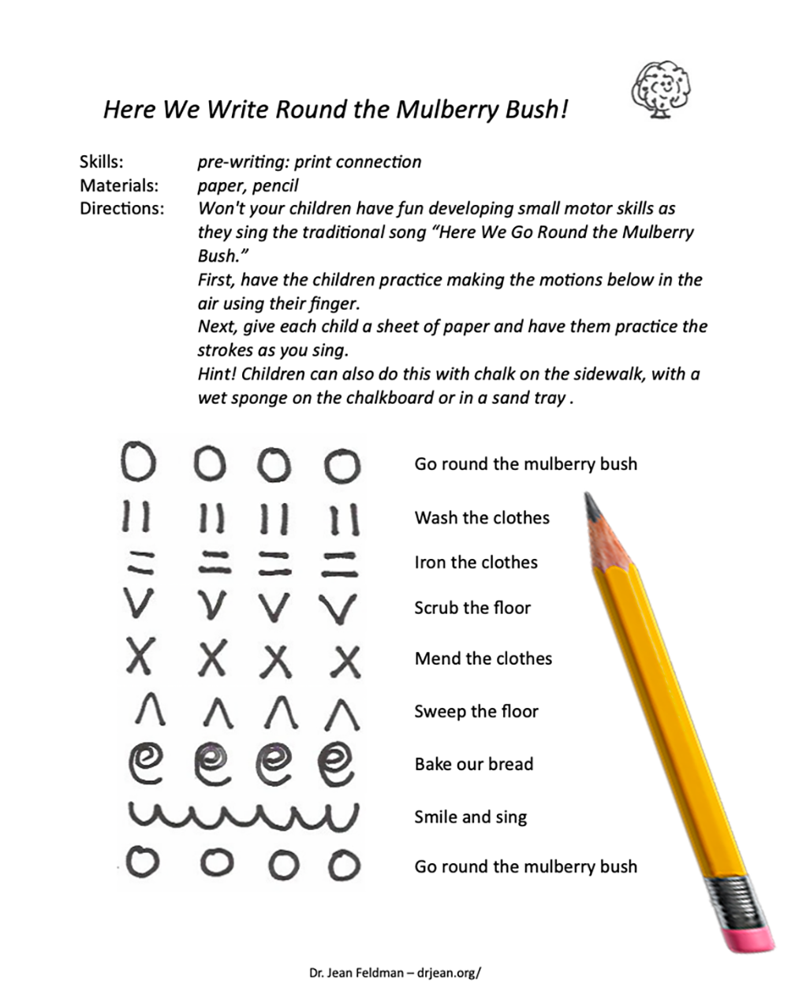
Here is a link to a Mulberry Bush video: https://bit.ly/drJMulberryYT

