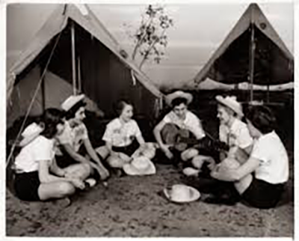

Here are some popular songs you might want to explore:
1. Camp Granada
2. This Land Is Your Land
3. Ain't No Flies on Us
4. I Like Bananas
5. Hey Ho Nobody Home
Links below for some of these popular songs.
6. Do Your Ears Hang Low
7. My Bonnie Lies Over the Ocean
8. You're A Grand Old Flag
9. Home on the Range
10. Going on a Bear Hunt
11. Baby Fish
12. Little Bunny Foo Foo

