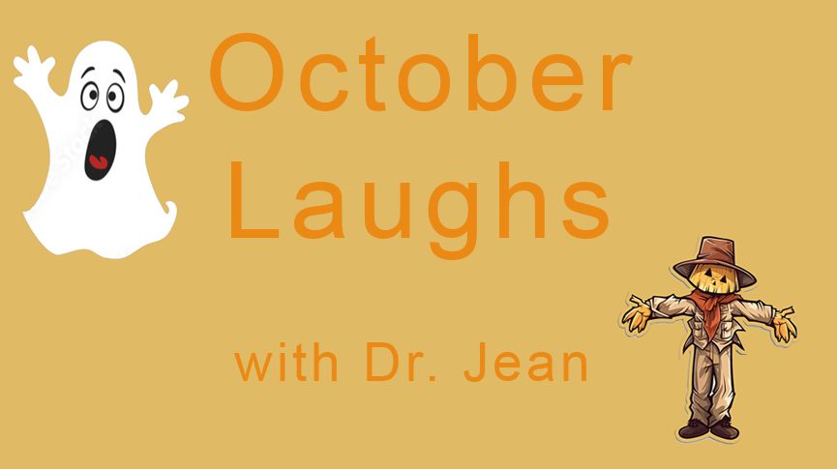

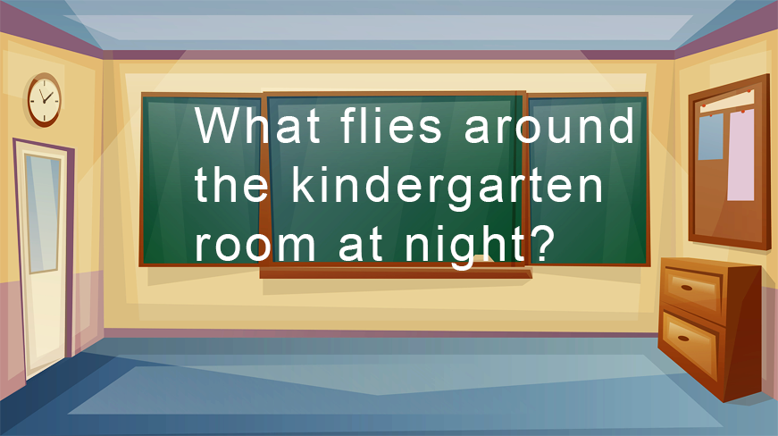

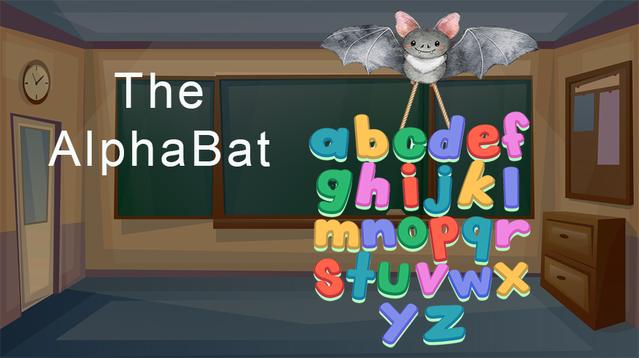

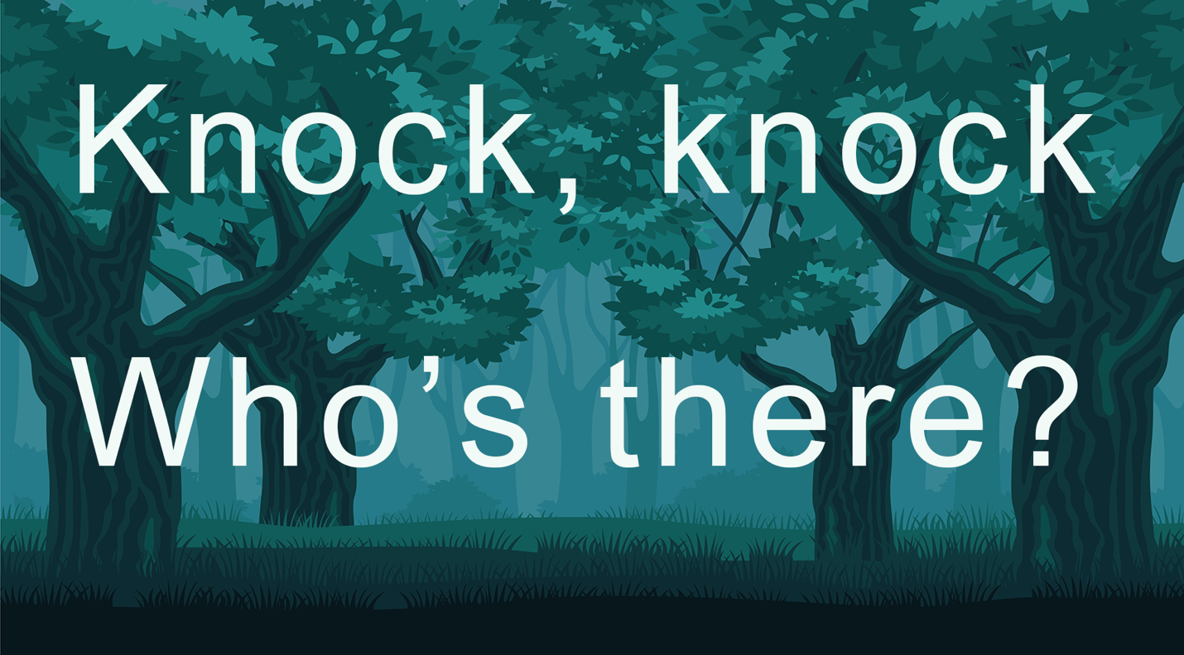

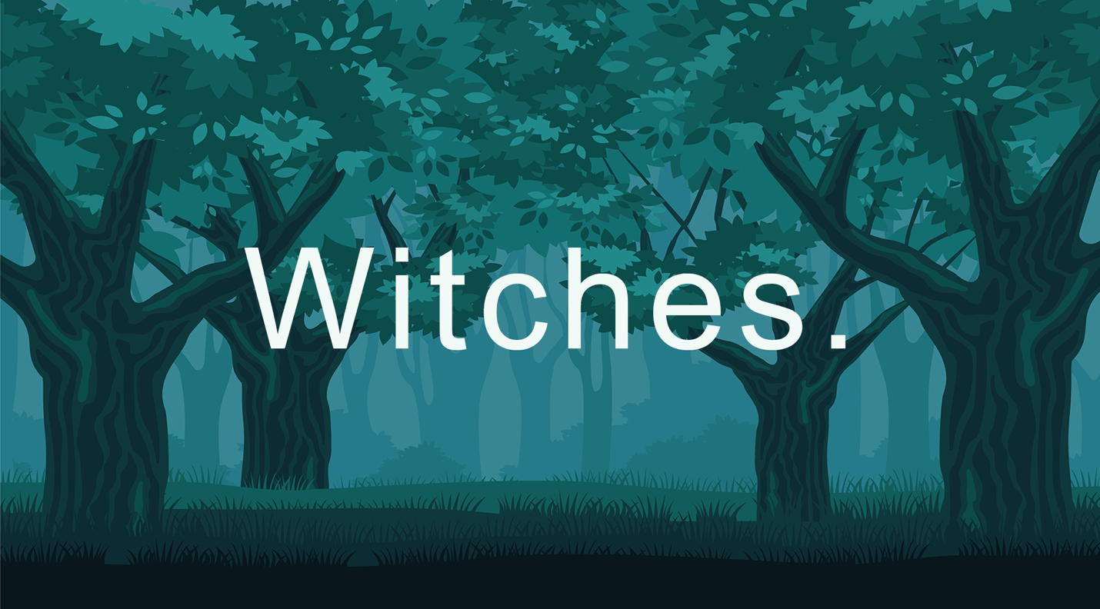

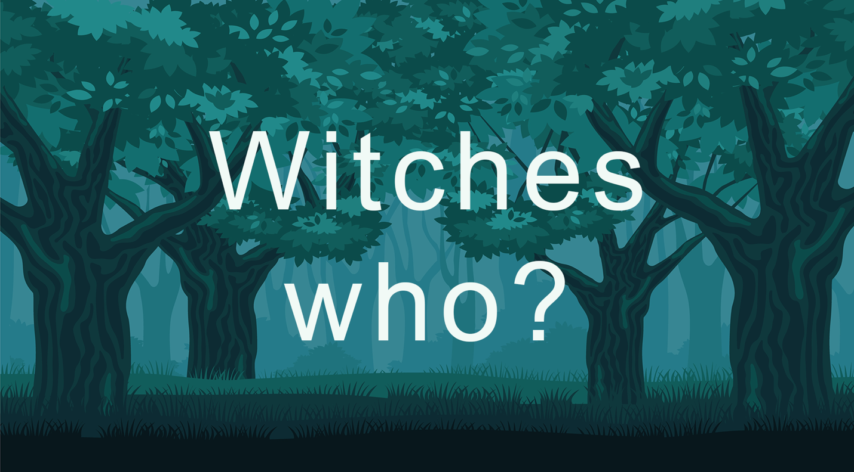

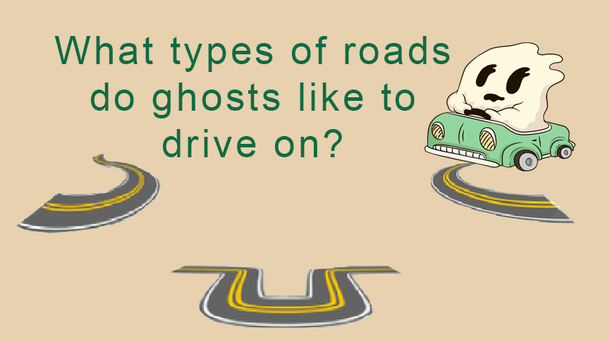
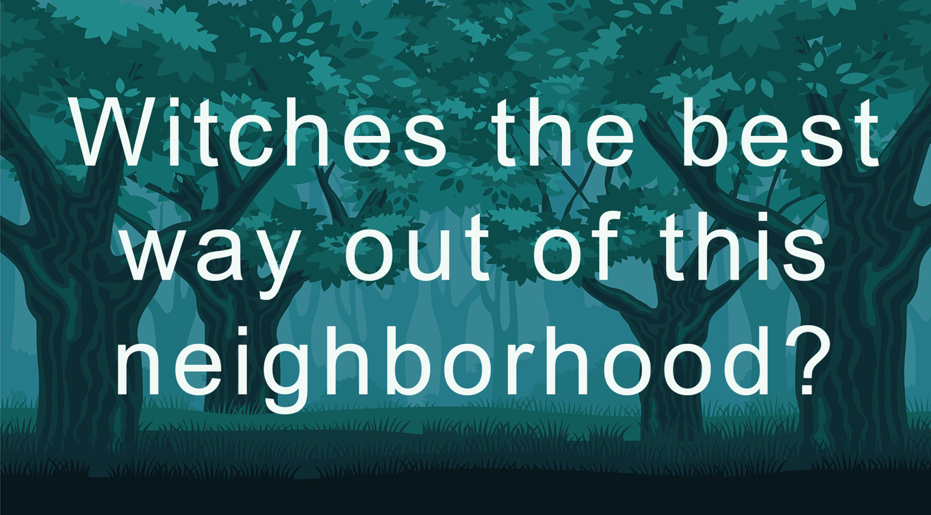

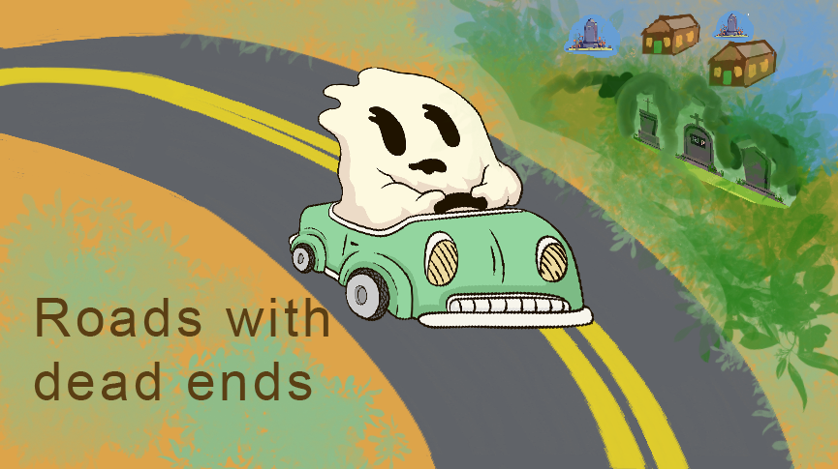

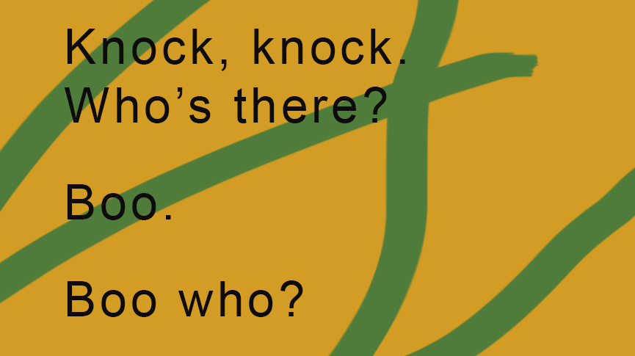

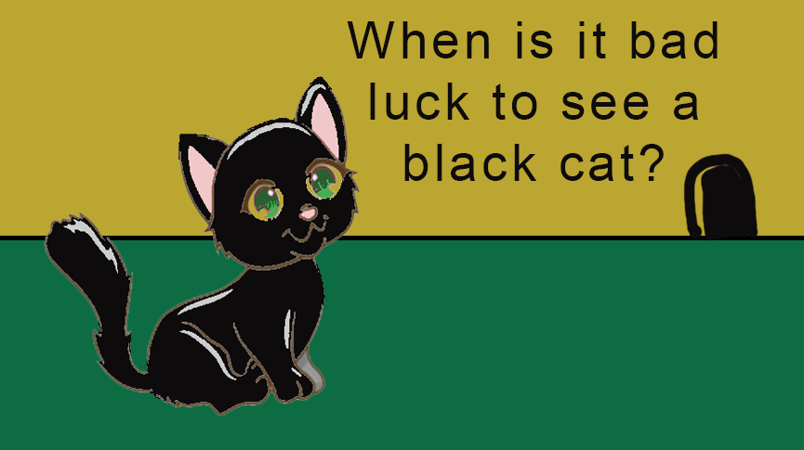
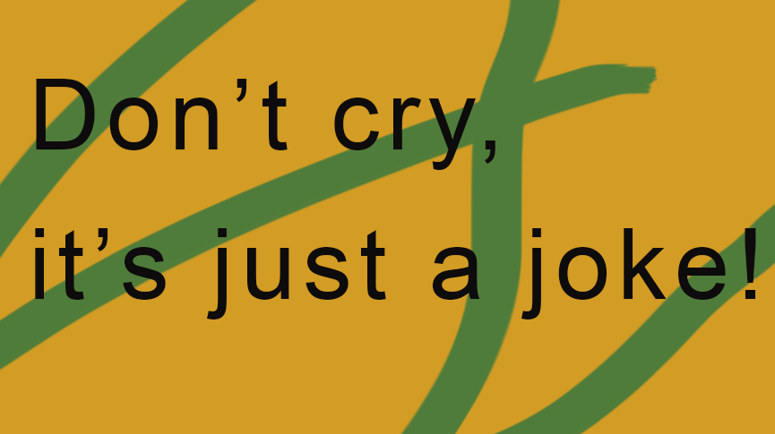
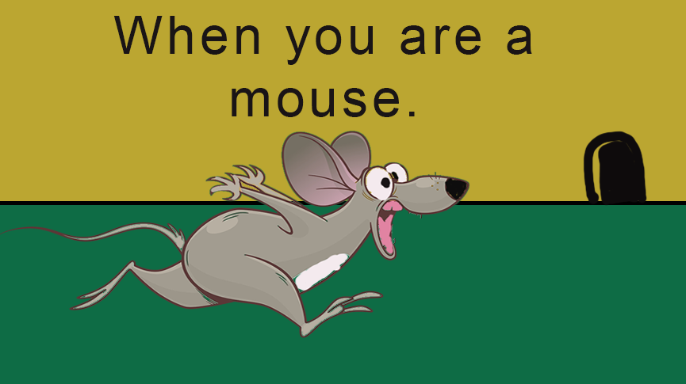

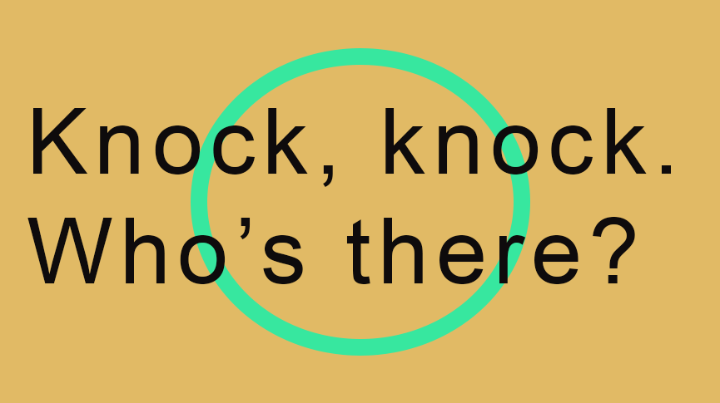

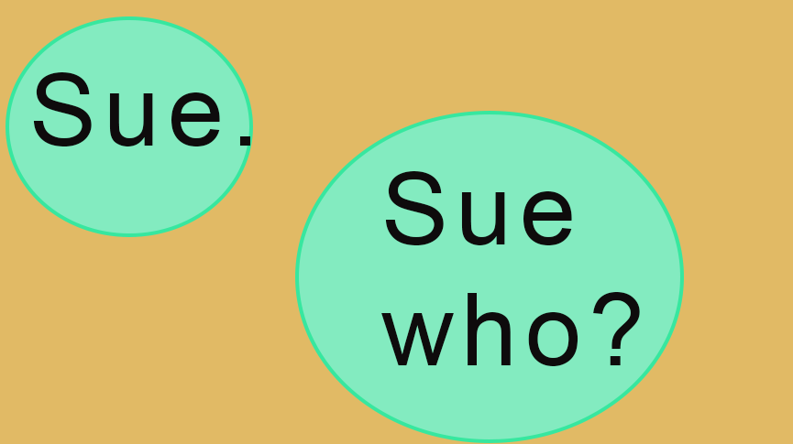

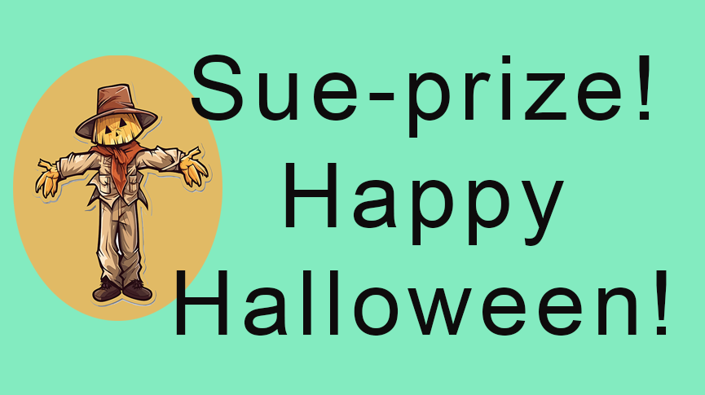

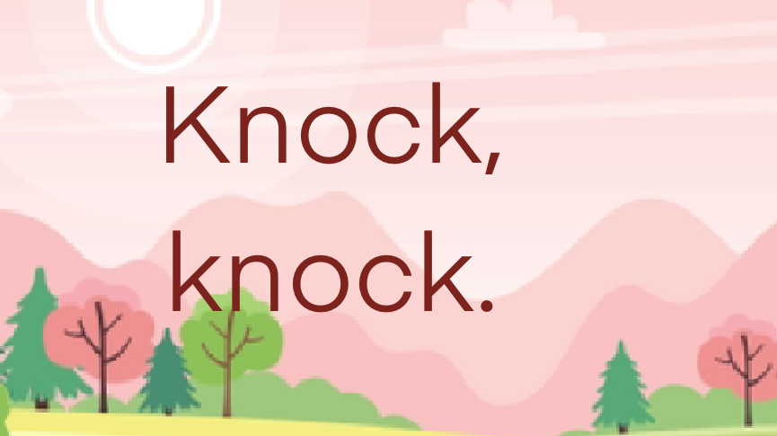

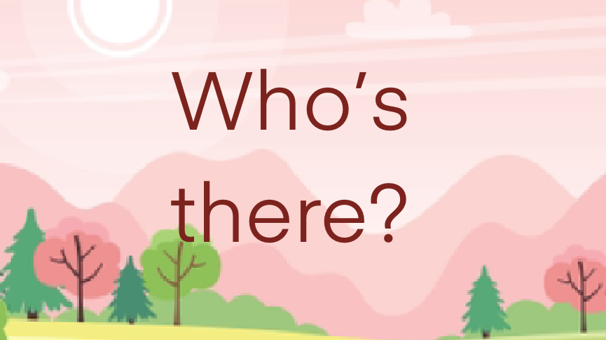

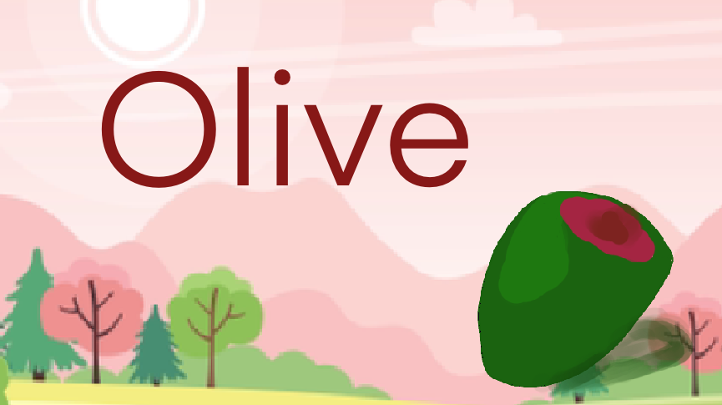

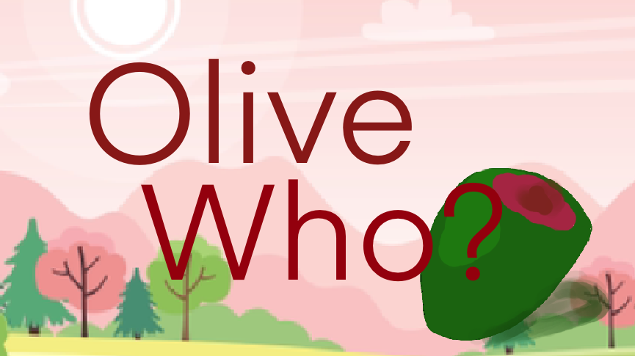

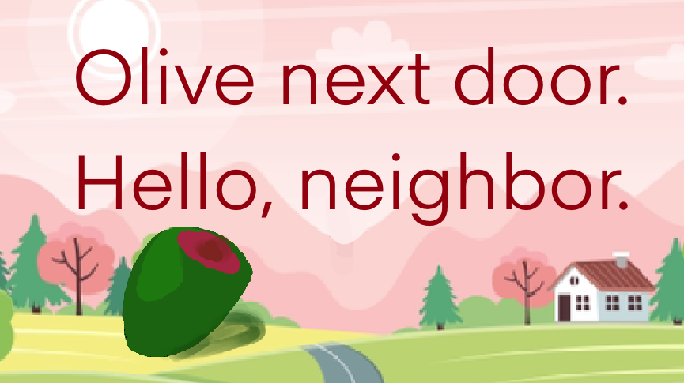

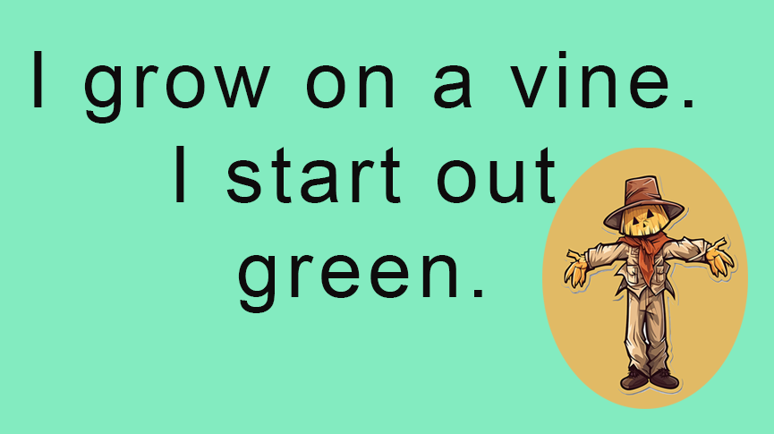

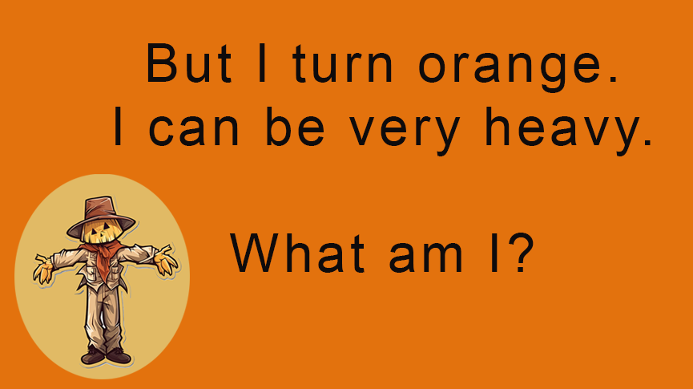

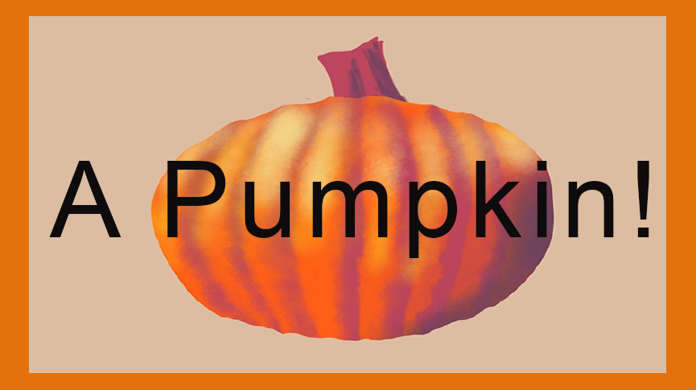

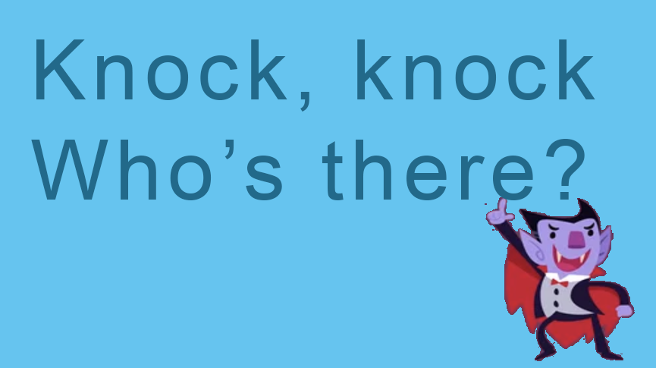

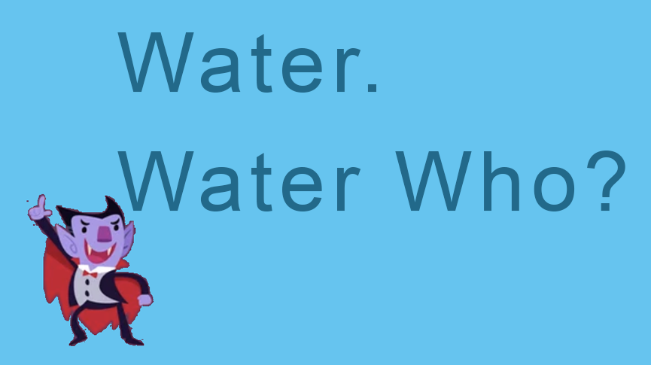

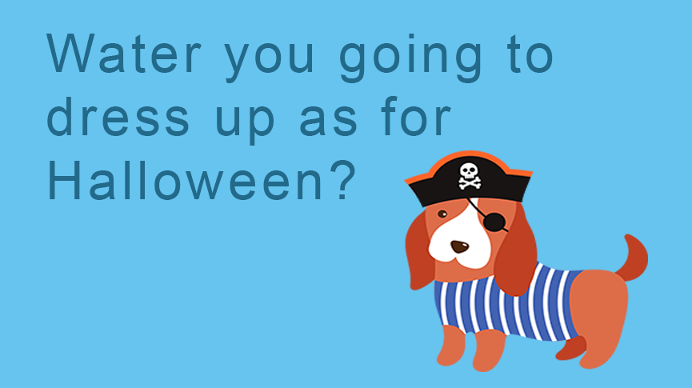

We hope you and your students enjoyed the video and these cards. Here are some links to other Dr. Jean resources.

Visit Dr. Jean's website: http://drjean.org/

Subscribe to Dr. Jean's blog: http://drjeanandfriends.blogspot.com/

Learn about Dr. Jean's eBooks: http://drjean.org/html/songs/songStore_eBooks.html

Dr. Jean now has some of her books available on Amazon Kindle as eBooks and paperbacks. You can find more information here:

Worksheet Avengers - https://amzn.to/457xqRX
Happies – Back to School - https://bit.ly/48tK3JS
Happies – October - https://amzn.to/46cNyCX

Riddles are wonderfully enticing and encourage youngsters to think, collaborate and learn.

What might they learn? Very importantly, they learn problem solving skills. They isolate important details, discard distracting elements and build a new thought process.

Hopefully, good riddles will help increase vocabulary as well.

Kids enjoy hearing riddles and working to solve them. Teachers and parents can use riddles and efforts to solve riddles to help develop a love for learning now and in the future.

Preview this video before showing it to your students. Stop the video at points where a question has been posed, but no answer has yet been revealed.

Discuss possible solutions with your youngsters. Start the video back up and let the students see how close they came to a solution.

Sometimes their suggestions will develop alternative solutions that are as valid as the one provided in the video.

Whatever you do, have fun with this video and encourage your students to discuss and verbalize their solutions.

Take time to discuss how they arrived at their solutions. Allow them to defend their solutions and their problem solving strategies.

Riddles can be wonderful tools in a classroom.

